SOCIAL STUDIES 30-1

Essay Case Studies

Economic

Communism/ Command Economy/ Centrally Planned/ Planned / Marxism
(Rejection of Liberalism)
Problems with Communism
- Corruption
- Lack of effective incentives, no motivation
- Low level of innovation
- Everyone is poor
- Limited freedom
Examples
North Korea
Cuba
USSR – Joseph Stalin
- 5 yr. plans
- Collective farms
  - Kulaks – Gulags (work Camps)
- Holodomor - Ukrainian Famine
Essential Elements
Equality
Gov’t control replaces the role of Supply & Demand
Classless society
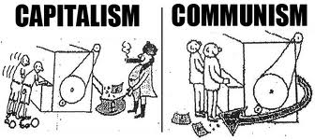
Philosophers
Karl Marx

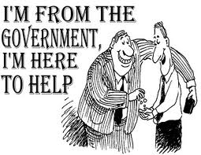
Welfare State
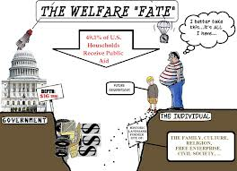
Examples
Sweden
Canada
- Healthcare Debate
- Social Programs
  - Welfare
  - Employment Insurance
  - Child tax credit
  - Old age Pension
- Taxation
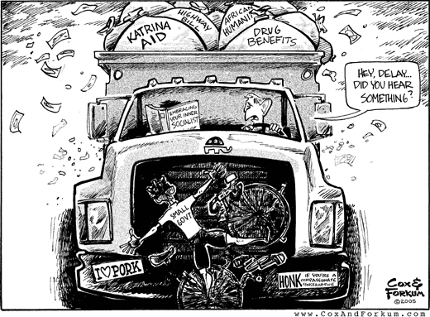
- Education
Keynesian Economics
Roosevelt’s New Deal – Hoover Dam
Philosophers

Welfare Capitalism
United States

Welfare capitalism refers to capitalist economies that involve a comprehensive social welfare policy in the form of a welfare state, where the welfare state is predominantly financed through taxes levied on privately-owned enterprises or through income taxes. Alternatively, welfare capitalism refers to the practice of businesses providing welfare services to their employees.
Problems with Capitalism
- Monopolies
- Takes money to make money
  - Rich get richer and the poor get poorer
- Rich exploit the poor (low wages)
- Classes (low-middle-high)
- Poor, old, Sick and Lazy don’t get taken care of by the gov’t
- Industrial Revolution
- American Industrial Revolution
- Great Depression

Capitalism
Example
United States
Essential Elements
Business cycle
Private Property
Supply and Demand
Competition
Invisible Hand
Philosophers
Adam Smith
Friedrich Hayek
Milton Friedman
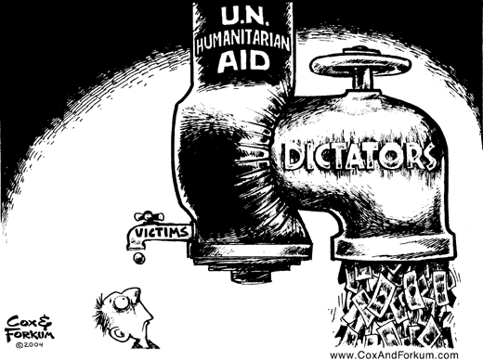
Political

Totalitarian Dictatorship
(Rejection of Liberalism)

Stalin / Hitler / Mussolini / Kim Jong-Un :North Korea
- Secret Police
- Indoctrination
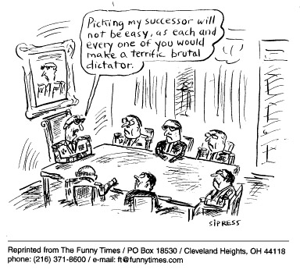
  - Propaganda
  - Education
  - Youth Groups
  - Censorship (control of the media)
- Scapegoating (Direction of Popular Discontent)
- Fear/Intimidation
  - Gulags (Russian)
  - Concentration camps (Nazi)

Dictators
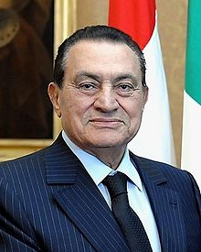
Cuba: Fidel Castro, China: Mao Zedong
Arab Spring
- Movement towards Liberalism and political freedom

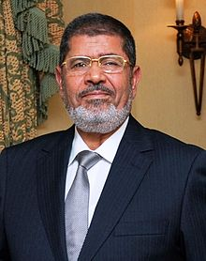
Egypt - Hosni Mubarak
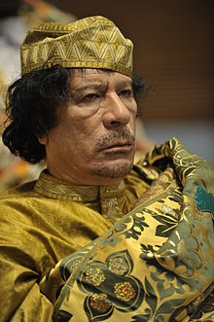
- Mohamed Morsi

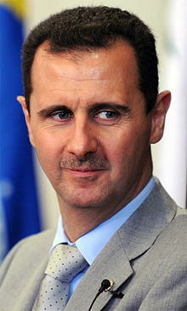
Lybia - Muammar Gaddafi

Syria - Bashar al-Assad

Liberal Democracies
Representative Democracies
Canada’s illiberal acts (rejection of liberalism)
- Party Solidarity
- Appointed Senate
- War Measures Act
  - Internment camps
  - Conscription
  - FLQ Crisis (Oct Crisis)
- Canadian Emergencies Act
- No fly List
- Anti Terrorism Act
- Aboriginal Assimilation
  - White paper
  - Residential Schools
Canada
- Rep. by pop
- Universal Suffrage
- Free and open elections
- House of Commons

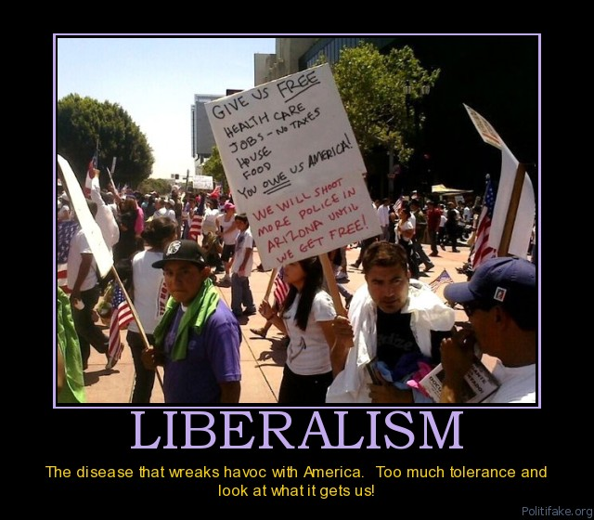

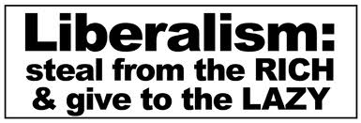

United States
- College electoral Vote
- Direct Election of President
- Senate elections
- System of Checks and Balances
Illiberal acts
- The Patriot Act
- Airport Securities
- No fly List
- Guantanamo bay
- Containment / Truman Doctrine
- Separation of Powers

Imposing Liberalism
- Afghanistan
- Iraq
- NATO in Libya
- Cold War – Korean War / Vietnam War / Bay of Pigs / Marshal Plan

Proportional Government
Sweden, Germany, many European and South American Governments
% of votes for a political party = % of seat in parliament for a political party

Direct Democracy

Everyone Votes on all Issues
Ancient Greece
Referendum / Plebiscite
Although very Liberal - Not viable
- Not economical – in Canada it cost 25 million for an election
- Slow
- Inefficient
- Canada’s Referendums
  - Meech Lake Accords
    - Quebec Sovereignty
  - Charlotte Town Accords
    - Quebec Sovereignty
  - Conscription during WWII
  - Prohibition 1898

