CAPITALISM - MARKET ECONOMY
(FREE ENTERPRISE. FREE MARKET ECONOMY)

The market economy is an economic system where the means of production (land, labor, capital) are all owned and controlled by individual producers and consumers. The basic economic questions are all answered by those same individual producers and consumers. Ideally there is no government intervention in the economy.
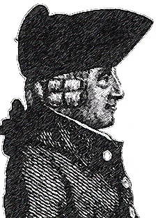
Thinker/Philosopher

Economic principles based on the ideas of Adam Smith - he authored the Wealth of Nations. He believed the government had no role in the operation of the economy. He believed that an 'invisible hand' represented by individual self interest would effectively control economic matters. He believed in a 'laissez faire' or hands off approach with respect to government involvement in the economy.

Values

The main values held by believers in this system are:

- individualism - people look out for their own self interest
- little or no government intervention in the economy – ‘laissez faire’
- competition - competition forces people, businesses and products to get better, while there is an acceptance of 'winners' and 'losers'
- supply and demand - belief that the interaction of these two realities will dictate the price of goods in the market place
- profit motive - people are driven to make money and acquire wealth - people can achieve the so-called 'American Dream' - become rich and successful
- materialism - people believe the goods they posses define the quality of their lives, making them covet material (consumer) goods

Advantages

- individualism - everyone is unique because of choices that can be made
- consumer sovereignty - freedom to choose as a consumer - many products to choose from in a variety of market places
- competition - creates lots of choice , cheaper prices, better quality, forces people, businesses and products to. get better
- freedom - politically and economically; can change and influence things that are not liked;
have a say
- success - the "American Dream" - potential to be successful; social mobility
- on average a high quality of life for people

Disadvantages

- competition - with winners there are also losers - government does not establish
extensive social programs ('social safety net') so losing out can create problems like:
  - homelessness
  - crime
  - poverty
- inequality - competition amongst people can create tension and conflict - racial etc.
- profit motive - the profit motive overshadows everything including concern for individual and environmental concerns - mixed up priorities can lead to serious problems
- because of so much competition there is sometimes overproduction (duplication) of consumer goods which wastes resources.

Although not a pure capitalist system, the best example of a market economy is the United States of America.

COMMAND ECONOMY - COMMUNISM
(CENTRALLY PLANNED ECONOMY, PLANNED ECONOMY)
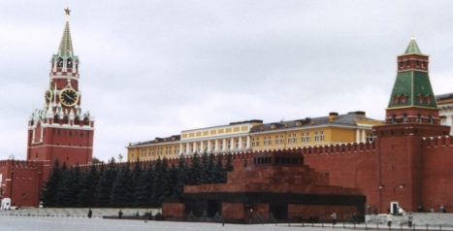
The centrally planned economy is an economic system where the means of production (land. labor. capital) are all owned and controlled by the government or state on behalf of the people. The basic economic questions are all answered by the government or state - usually through a central planning agency.
ie. Gosplan in Former USSR

Thinker / Philosopher

Economic principles based on the ideas of Karl Marx and Friedrich Engels - they co-authored the Communist Manifesto. They believed the working class (proletariat) would rise up and overthrow the rich factory and landowners, and seize control for the benefit of all.

Values
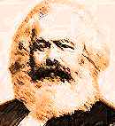
The main values held by believers in this system are:

- equality or egalitarianism– people should sacrifice personal wants for the good of society (collective good)
- collectivism – living life for the collective good of society, as opposed to individualism

Marx believed that within the economic system the following idea should preside over everything:

"From each according to ability, to each according to need."

Advantages

- equality - everyone is seen as an equal part of society no unemployment - everyone has a job to do
- centralized control of economy allowed leaders (Gosplan in former Soviet Union) to make decisions quickly – allowed Stalin to industrialize rapidly
- little waste of resources, or duplication of products, because there is only one producer- the government (state)

Disadvantages

- no openness to criticize the system
- little incentive - workers know they will only get what is planned for – based on equality
- little employment sovereignty - you must work where you are assigned - cannot quit or
strike – unions illegal
- little or no consumer-sovereignty – one producer and little choice
- shortages of consumer goods – small central planning mistakes lead to shortages
- no competition (one producer - the state) causes low quality goods
- lack of consumer goods leads to second economy (black market)
- on average (compared to the West) the quality of life is low
- central control of economy allows leaders to prioritize – industrialization under Stalin, ‘Cold War’ competition (arms race, space race etc.) under leaders like Khrushchev and Brezhnev.

Industrialization in the Soviet Union occurred amazingly fast, but at the cost of millions of
lives. Stalin sacrificed the needs of his citizens in order to meet the economic needs of his newly industrializing country (ie. the Great Famine in the Ukraine).

Other examples of command economies can be found in the countries of Cuba, China. North Korea

MIXED ECONOMY – DEMOCRATIC SOCIALISM

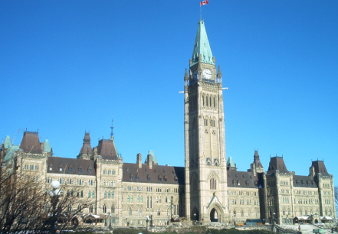
The mixed economy is an economic system where the means of production (land. labor. capital) are all owned and controlled by individual producers and consumers, as well as with some government involvement in certain areas. The basic economic questions are all answered by those same individual producers and consumers, again with some government involvement in certain areas. The goal of a mixed system is to adopt as many of the advantages of the two previous system as possible.

Thinker / Philosophers

John Stuart Mill (1806-1873) believed in Adam Smith's fundamental ideas, but believed the government needed to step in to correct the abuses of industrialization. He admired the productivity of the capitalist systems but believed peoples basic needs were important and needed to be protected. Mills work lead to improvements for workers during the industrial revolution.
John Maynard' Keynes (1883-1946) argued that the government could reduce unemployment and economic depression (he witnessed the 'Great Depression') by adjusting its policies on taxation, spending, and banking. He stated that the goal of the economy was to achieve the greatest amount of production and employment. Keynes argued the government could stimulate the economy during a depression by constructing public works and by lowering taxes. He believed in deficit financing if necessary.

Values

The main values held by believers in this system represent the best of the centrally planned and the market systems. The benefits of competition, individual freedom, balanced with government intervention to achieve equality in key areas. The difficulty in all economies is determining this balance.

Case Study: Canada

Canada is a country where many of the advantages of market economy are enjoyed. Both the public sector (government owned and operated) and private sector (private individual owners) operate, for the most part, in competitive and free environments, that are controlled by market forces of supply and demand.
The government (at its different levels - federal, provincials, municipal) gets in involved in the economy in areas it feels are essential for all people - in order to achieve equality of access. Sometimes these are areas that are essential to the country, but are not profitable to the private sector so the government must step in and exert control. Some examples of such areas are:

education postal service utilities - electricity, water
military - defense health care roads
regulations – safety, food inspection

The Canadian government also gets involved to stop people from hitting “rock bottom” (extreme poverty, homelessness etc.). They set up a 'social safety net’ of social programs such as:

Social Assistance - welfare Canada Pension Plan (CPP)
Workman's Compensation Employment Insurance (EI)
Family Allowance

These programs cost a lot of money so Canadians pay taxes (redistribution of wealth) to help pay for the costs. We pay income taxes, general sales tax (GST), provincial sales taxes (except Alberta), corporate taxes, property taxes etc. We are heavily taxed compared to people in many other countries.


The government of Canada also directly owns and controls certain businesses, in which they profit from - they are known as crown corporations. An example would be Petro-Canada.

The Canadian government also gets involved in the economy through the Bank of Canada. The Bank of Canada sets the prime interest rates that banks adjust to accordingly. Through this means, the government can influence Canada's monetary policy.

If interest rates are lowered this can encourage consumer borrowing and then spending. Whereas, if interests rates are increased, then borrowing and subsequent spending is discouraged, and this can help slow-down inflation.

Case Study: Sweden

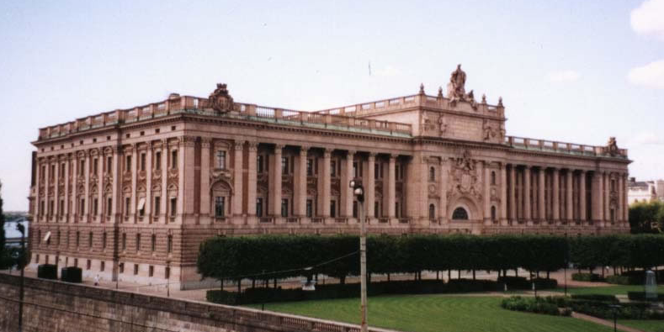
Sweden is a mixed economy in which the government leaves the economy and business largely left to profit on their own, but the government collects many taxes from people to redistribute the wealth in a 'cradle to grave' set of social programs - people are well taken care of by the government. In the past, the Swedish people paid the highest taxes in the world. Many people pay as high as 50-70% percent of their yearly income towards taxes for these extensive social programs. A healthy partnership between business, labor unions and government runs
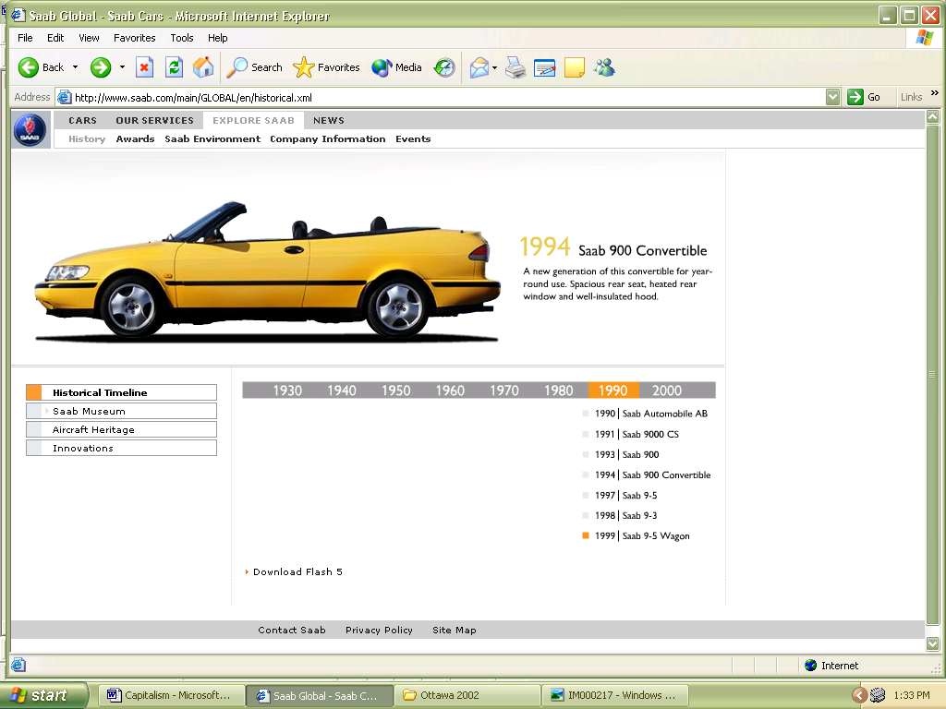

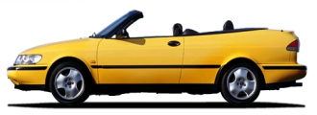
the economy. Because of this there are few strikes and businesses that do not do well are allowed to fail. It would seem the economy is largely run by market forces. Sweden's government sets five-year plans, similar to the Former Soviet Union, but the plans are only economic forecasts for the private sector - they indicate where the economy might be going. This relationship has been coined indicative planning. Sweden boasts many successful multinational corporations that have thrived in Sweden under their system, and now they are thriving in the international marketplace as well.

Mixed Economies – General Comments

Mixed economies exist in many countries around the world. Other prominent case studies would include the western European nations of Great Britain, France, Holland, Belgium, as well as northern European countries like Norway and Finland.
In practice, every economy in the world is some form of a mixed economy, but there are vast differences between them in terms of how much of each economic ideology they support. Generally though, mixed economies will have areas that are public (closest in principle to the centrally planned economy) and areas that are private (most similar to a capitalist system).
Issues like taxation manifest themselves in mixed economies because they are the primary way of redistributing wealth. Citizens pay taxes to various levels of government, and in-turn, the governments provide services to the citizens. People living in mixed economies need to decide what they want the government to provide and control (public sector and nationalized industries), and what they want individual citizens, private businesses and corporations to operate in the open marketplace, free of government influence (private sector and deregulated or privatized industries).
Governments of mixed economies are sometimes forced to make difficult decisions about how to maintain services to their citizens if tax revenues are not able to cover the costs of providing those services. They may need to overspend and run deficits (deficit-financing), and accumulate debt, both politically and economically dangerous choices.

