Social 30 Name: _______________
Unit 2d Alternative Thought Date: _______________

Examine the extent to which modern liberalism is challenged by alternative thought
Examine judgments of liberalism

Contemporary alternatives to liberal principles and values do exist, although they are not always widely supported.
- Aboriginal collective thought
- Environmentalism
- Religious Perspectives
- Neo-Conservatism
- Postmodernism extremism: a movement that largely began as a reaction to modernism after the 1st and 2nd World Wars. “Postmodernism calls into question enlightenment values such as rationality, truth, and progress, arguing that these merely serve to secure the monolithic structure of modern capitalistic society by concealing or excluding any forces that might challenge its cultural dominance” see pages 406-415 in textbook).

Media accounts of various protests
Using the Internet and/or newspaper, examine media accounts to determine alternative thoughts represented and identify the principles of liberalism being opposed. In addition, identify actions taken in support of the alternative thought and record reasons for opposition. See below for an example.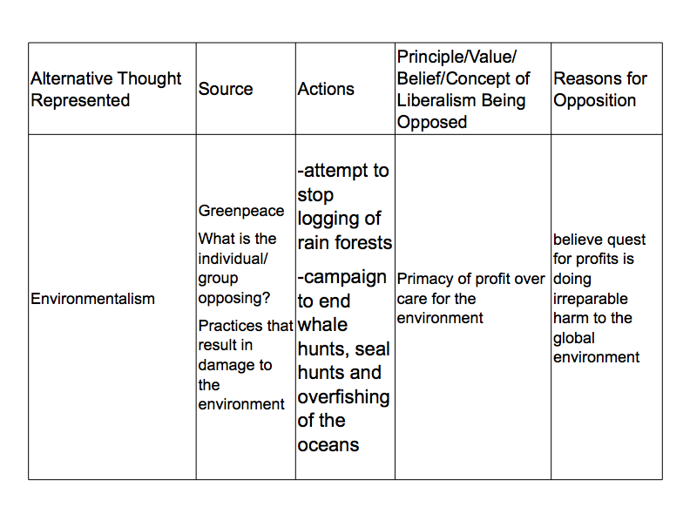

Identify what issues and concerns may have prompted protesters to act. For example, they may be issues and concerns associated with free trade and globalization.
Assess alternatives to liberalism
Using your handout Assessing Alternatives to Liberalism, determine the extent to which these alternatives provide challenges to the principles of liberalism. Use the following criteria and research to make conclusions on alternatives to liberal thought. Space has been provided in the retrieval chart for you to include additional criterion. Criteria for a valid alternative to liberalism might include the following:
- feasibility
  - Are these alternative ideas possible and workable?
  - Would it be practical to implement these ideas?
- effectiveness
  - Will these ideas address perceived problems and shortcomings of liberalism?
  - Will these ideas produce desirable results?
- sustainability
  - To what extent will these ideas be supported?
Will these ideas work over the long term?

Questions to Consider

Which principles of liberalism appear to prompt the greatest concern?

Why do various individuals and groups object to the principles of liberalism?

How do advocates of liberal principles and values respond to such challenges?

